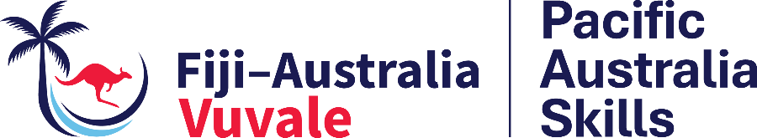

AUSTRALIA AND FIJI LAUNCH PACIFIC AUSTRALIA SKILLS AND OPEN VUVALE SKILLS HUB

6 July 2026

Suva, Fiji – Today Australia and Fiji launched Pacific Australia Skills and opened the Vuvale Skills Hub in Walu Bay – celebrating the two countries’ joint efforts to strengthen skills, create more employment pathways, and contribute to a more sustainable economy for all Fijians.

Pacific Australia Skills is the Australian Government’s new regional skills and training program for the Pacific and Timor-Leste. In Fiji, it is working with government, training providers, industry, employers and communities to strengthen the national skills system and expand access to practical, industry-relevant training.

The program builds on the achievements of the Australia Pacific Training Coalition (APTC), which supported more than 13,000 Fijians to access qualifications, short courses, micro-credentials and other training opportunities between 2007 and 2025.

The launch reflected the depth of the Fiji-Australia Vuvale Union and the two countries’ shared commitment to strengthening skills and creating opportunities for all Fijians.

“The best investment any nation can make is in its people. That is why investment in education and skills are a foundational part of the Vuvale Union that Prime Minister Rabuka and I signed,” Australian Prime Minister, the Hon Anthony Albanese MP said.

Under the Vuvale Union and through Pacific Australia Skills, Australia and Fiji will collaborate on a new initiative to establish local TVET Centres of Excellence, which will deliver skills and training that drive economic growth.

“This is not only about training individuals; it is about building long-term capability within Fiji. We want to strengthen our own workforce, develop local expertise, and create opportunities for Fijian to pursue rewarding careers in government service and the wider economy,” Fiji’s Minister for Public Works, Transport and Meteorological Services, the Hon Ro Filipe Tuisawau said.

So far, 479 Fijians have benefited from Pacific Australia Skills training and skills system strengthening in employability, agriculture, youth work, meat processing, teacher development, inclusion, trauma-informed practice and youth leadership.

In addition, Pacific Australia Skills recently refurbished the Vuvale Skills Hub, providing a space for government, training providers, industry and other skills stakeholders to deliver training, collaborate, share resources and strengthen practical learning.

The hub includes construction and automotive workshops, tools, training equipment and classroom space, enabling learners from different training providers to collectively use the space to build workplace-relevant skills.

Through our Vuvale Union, Australia will continue to work with Fiji to expand priority training opportunities, strengthen Fiji’s TVET system, and support Fiji’s first-ever National Skills Competition in 2026.

ENDS

For more information:
Public Affairs Team
Australian High Commission, Fiji
public-affairs-suva@dfat.gov.au

